**Tagline**

**"Clean Environment is not a Luxury,  
But a Necessity for Everyone!"**

**We study fluid-mediated surficial processes with isotopic precision**

[LEARN MORE] IF CLICKED DIRECT TO RESEARCH

TAB: HOME RESEARCH PEOPLE PUBLICATIONS FACILITIES TEACHING RECOGNITIONS

HOME

**"Clean Environment is not a Luxury,  
But a Necessity for Everyone!"**

**We study fluid-mediated surficial processes with isotopic precision**

[We need to find good pictures]

I NEED TO HAVE DATA LIKE

NO OF PUBLICATIONS 39/NUMBER OF PATENTS 3/PROJECT COMPLETED X/LIVE GOOGLE SCHOLAR CITATIONS

ORCHID ID/SCOPUS ID/GOOGLE SCHOLAR ID

VERY SIMILAR TO WEBSITE: <https://iitk.irins.org/profile/52371>

IN ADDITION: GIVE ADDRESS

ADMINSTRATIVE CONTACT: AS

CONTACT

Dr. Indra Sekhar Sen

IIT Kanpur

CESE 214

Kanpur, UP 208016

E-mail: [isen@iitk.ac.in](mailto:isen@iitk.ac.in)

Phone: +91—0512-679-6440

Administrative contact

Mr. Aditya Tripathi

IIT Kanpur

CESE 214

Kanpur, UP 208016

E-mail: [taditya@iitk.ac.in](mailto:taditya@iitk.ac.in)

Phone: +91—0512-679-7514





RESEARCH TAB

**Environmental Research “The Himalayas and Climate Change”**

### We use long-lived radiogenic and stable isotopes to trace fluid-mediated surficial processes in the Himalayas. We focus on glacier-fed headwater streams, glacial impurities, water end-member source contributions to total river discharge, and water-rock interactions in the glacierized in Himalayan catchment. We try to address fundamental questions such as sources, pathways, and control mechanisms of surface water ionic compositions. These endeavors collectively aim to illuminate the profound impact of climate change on the delicate Himalayan ecosystem. Some key finding of our research group includes:

* Discharge-weighted average ice meltwater contribution in headwaters of the Indus, the Ganga, and the Brahmaputra, varied between 47 ± 13%, 44 ± 13%, and 29 ± 10%, respectively, which is equivalent to 33.5 ± 6.5 Gt yr-1 of melted ice mass
* HNO3-mediated chemical weathering reactions are important processes that alter the geologic carbon cycle of high-altitude glacierized Himalayan catchments as well as on a global scale.
* Glacier fed small Himalayan lakes (≤0.04 km2) are a significant emitter of atmospheric CO2 controlled by DIC, and is an emerging—and not an inert—component of the regional carbon budget.
* Planetary boundary layer height dynamics in the Indo-Gangetic Plains, which are far from the Higher Himalaya, modulates pollutant transport to the high mountains of the Himalaya.
* Biomass-derived carbon could be the only primary driver of carbon-induced glacier melting in the western Himalaya.

Publications

(9) Pradhan, S. **\***, Sen, I.S., “Metamorphic CO2 fluxes offset the geological carbon sink in the Himalayan-Tibetan orogen,” **Earth and Planetary Science Letters *(****under revision)*

(8) Roy, N*, Sen I.S. CO2 consumption rates in the glacierized Himalayan headwaters: The importance of sulfuric and nitric acid-mediated chemical weathering reactions in geologic carbon cycle (2023). **Geochemistry, Geophysics, Geosystems**, 24, e2023GC010919, <https://doi.org/10.1029/2023GC010919>

(7) Shukla, T, ** Sen, I.S.; Sundriyal S., Carbon emissions from emerging glacier-fed Himalayan lakes, **Global and Planetary Changes,** Volume 225, June 2023, 104134<https://doi.org/10.1016/j.gloplacha.2023.104134>

(6) Mitra, A.,**\*** Sen, I.S., Pandey, S.K., Velu, V., Reisberg, L., Bizimis, M., Cloquet, C., Nizam, S.**\*** Lead Isotope Evidence for Enhanced Anthropogenic Particle Transport to the Himalayas during Summer Months; (2021) **Environmental Science and Technology**, 55 (20), pp. 13697-13708. <https://doi.org/10.1021/acs.est.1c03830>

(5) Nizam, S.,**\*** Sen, I.S., Shukla, T.,** Selby, D. Melting of the Chhota Shigri Glacier, Western Himalaya, Insensitive to Anthropogenic Emission Residues: Insights from Geochemical Evidence; (2021) **Geophysical Research Letters**, 48 (19), art. no. e2021GL092801. <https://doi.org/10.1029/2021GL092801>

(4) Shukla, T.,** Sen, I.S. Preparing for Floods on the Third Pole; (2021) **Science**, 372 (6539), pp. 232-234. DOI: 10.1126/science.abh3558

(3) Shukla, T.,** Sundriyal, S., Sen, I.S. Contemporary Inorganic Carbon Fluxes from Rapidly Changing Glacierized Watersheds of the Himalaya; (2020) **Journal of Hydrology**, 587, art. no. 124972. <https://doi.org/10.1016/j.jhydrol.2020.124972>

(2) Nizam, S., **\*** Sen, I.S., Vinoj, V., Galy, V., Selby, D., Azam, M.F., Pandey, S.K., Creaser, R.A., Agarwal, A.K., Singh, A.P., Bizimis, M. Biomass-Derived Provenance Dominates Glacial Surface Organic Carbon in the Western Himalaya; (2020) **Environmental Science and Technology**, 54 (14), pp. 8612-8621. <https://doi.org/10.1021/acs.est.0c02710>

(1) Boral, S.,**\*** Sen, I.S. Tracing 'Third Pole' Ice Meltwater Contribution to the Himalayan Rivers using Oxygen and Hydrogen Isotopes; (2020) **Geochemical Perspectives Letters**, 13, pp. 48-53. doi: 10.7185/geochemlet.2013

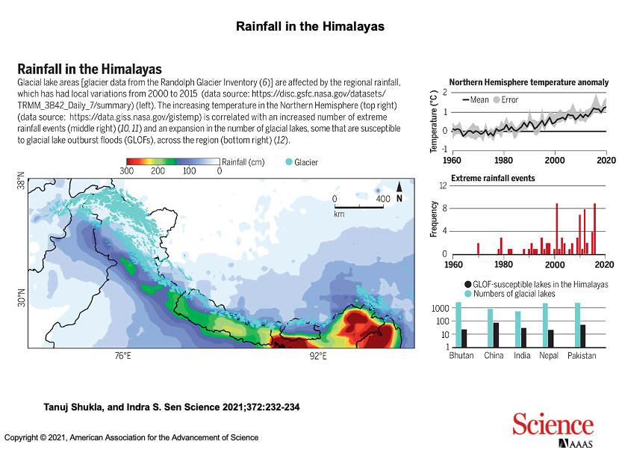

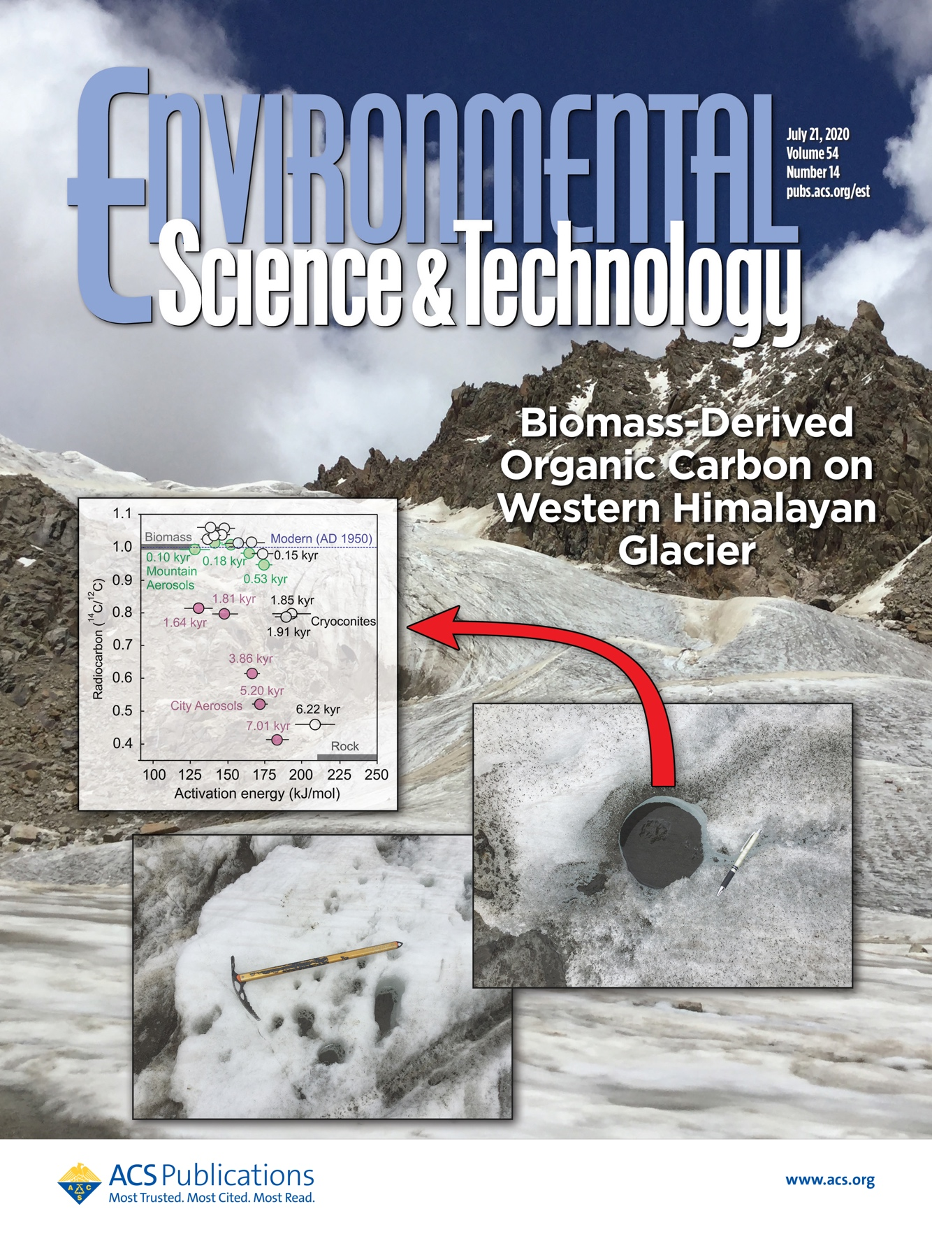

Environmental Research “Isotope hydrology”

### We study the influence of climate change, land-use land cover, and other disruptions on large rivers and groundwater resources. We try to address fundamental questions such as concentration-discharge relationships, chemical fluxes from land to ocean, sources, pathways, and controlling factors of dissolved constituents in rivers and groundwater using isotopic tracers. Some key finding includes:

* Uranium in the Ganga Basin alluvial aquifer system is geogenic in nature with bicarbonate complexation controlling its enrichment
* Dynamic sediment-water interactions in rivers possibly modify dissolved 87Sr/86Sr
* High resilience of heavy metals in large rivers

Publications

(8) Roy, N*, Sen I.S., Boral, S., Shukla T., Velu, V. Isotope hydrograph separation reveals rainfall on the glaciers will enhance ice meltwater discharge to the Himalayan rivers (2023). **Water Resource Research** *(under revision).*

(7) Shaifullah*, Sen I.S. A four-component mixing model reveals an early onset of snow meltwater runoff in the headwaters of River Ganga. **Journal of Hydrology**, [Volume 628](https://www.sciencedirect.com/journal/journal-of-hydrology/vol/628/suppl/C), January 2024, 130473, https://doi.org/10.1016/j.jhydrol.2023.130473

(6) Nizam S*., Dutta, S**‡**., Sen, I.S. Geogenic controls on the high levels of uranium in alluvial aquifers of the Ganga Basin; (2022) **Applied Geochemistry**, 143, 105374, <https://doi.org/10.1016/j.apgeochem.2022.105374>

(5) Boral, S.,**\*** Peucker-Ehrenbrink, B., Hemingway, J.D., Sen, I.S., Galy, V., Fiske, G.J. Controls on Short-Term Dissolved 87Sr/86Sr Variations in Large Rivers: Evidence from the Ganga–Brahmaputra; (2021) **Earth and Planetary Science Letters**, 566, art. no. 116958, <https://doi.org/10.1016/j.epsl.2021.116958>

(4) Shukla, T.,** Sen, I.S., Boral, S.,**\*** Sharma, S. A Time-Series Record during COVID-19 Lockdown Shows the High Resilience of Dissolved Heavy Metals in the Ganga River; (2021) **Environmental Science and Technology Letters**, 8 (4), pp. 301-306, <https://doi.org/10.1021/acs.estlett.0c00982>

(3) Boral, S.,**\*** Sen, I.S., Tripathi, A., Sharma, B., Dhar, S. Tracking Dissolved Trace and Heavy Metals in the Ganga River from Source to Sink: A Baseline to Judge Future Changes; (2020) **Geochemistry, Geophysics, Geosystems**, 21 (10), art. no. e2020GC009203, <https://doi.org/10.1029/2020GC009203> [Research spotlight: Shultz, D. (2020), Tracking trace elements in the Ganga River, Eos, 101, <https://doi.org/10.1029/2020EO150385>]

1. Sen, I.S., Boral, S.,**\*** Ranjan, S.,**‡** Tandon, S.K. Small but Important: The Role of Small Floodplain Tributaries to River Nutrient Budgets; (2018) **ACS Earth and Space Chemistry**, 2 (1), pp. 64-71. <https://doi.org/10.1021/acsearthspacechem.7b00112>
2. Boral, S.,**\*** Sen, I.S., Ghosal, D., Peucker-Ehrenbrink, B., Hemingway, J.D. Stable Water Isotope Modeling Reveals Spatio-Temporal Variability of Glacier Meltwater Contributions to Ganges River headwaters; (2019) **Journal of Hydrology**, 577, art. no. 123983. <https://doi.org/10.1016/j.jhydrol.2019.123983>

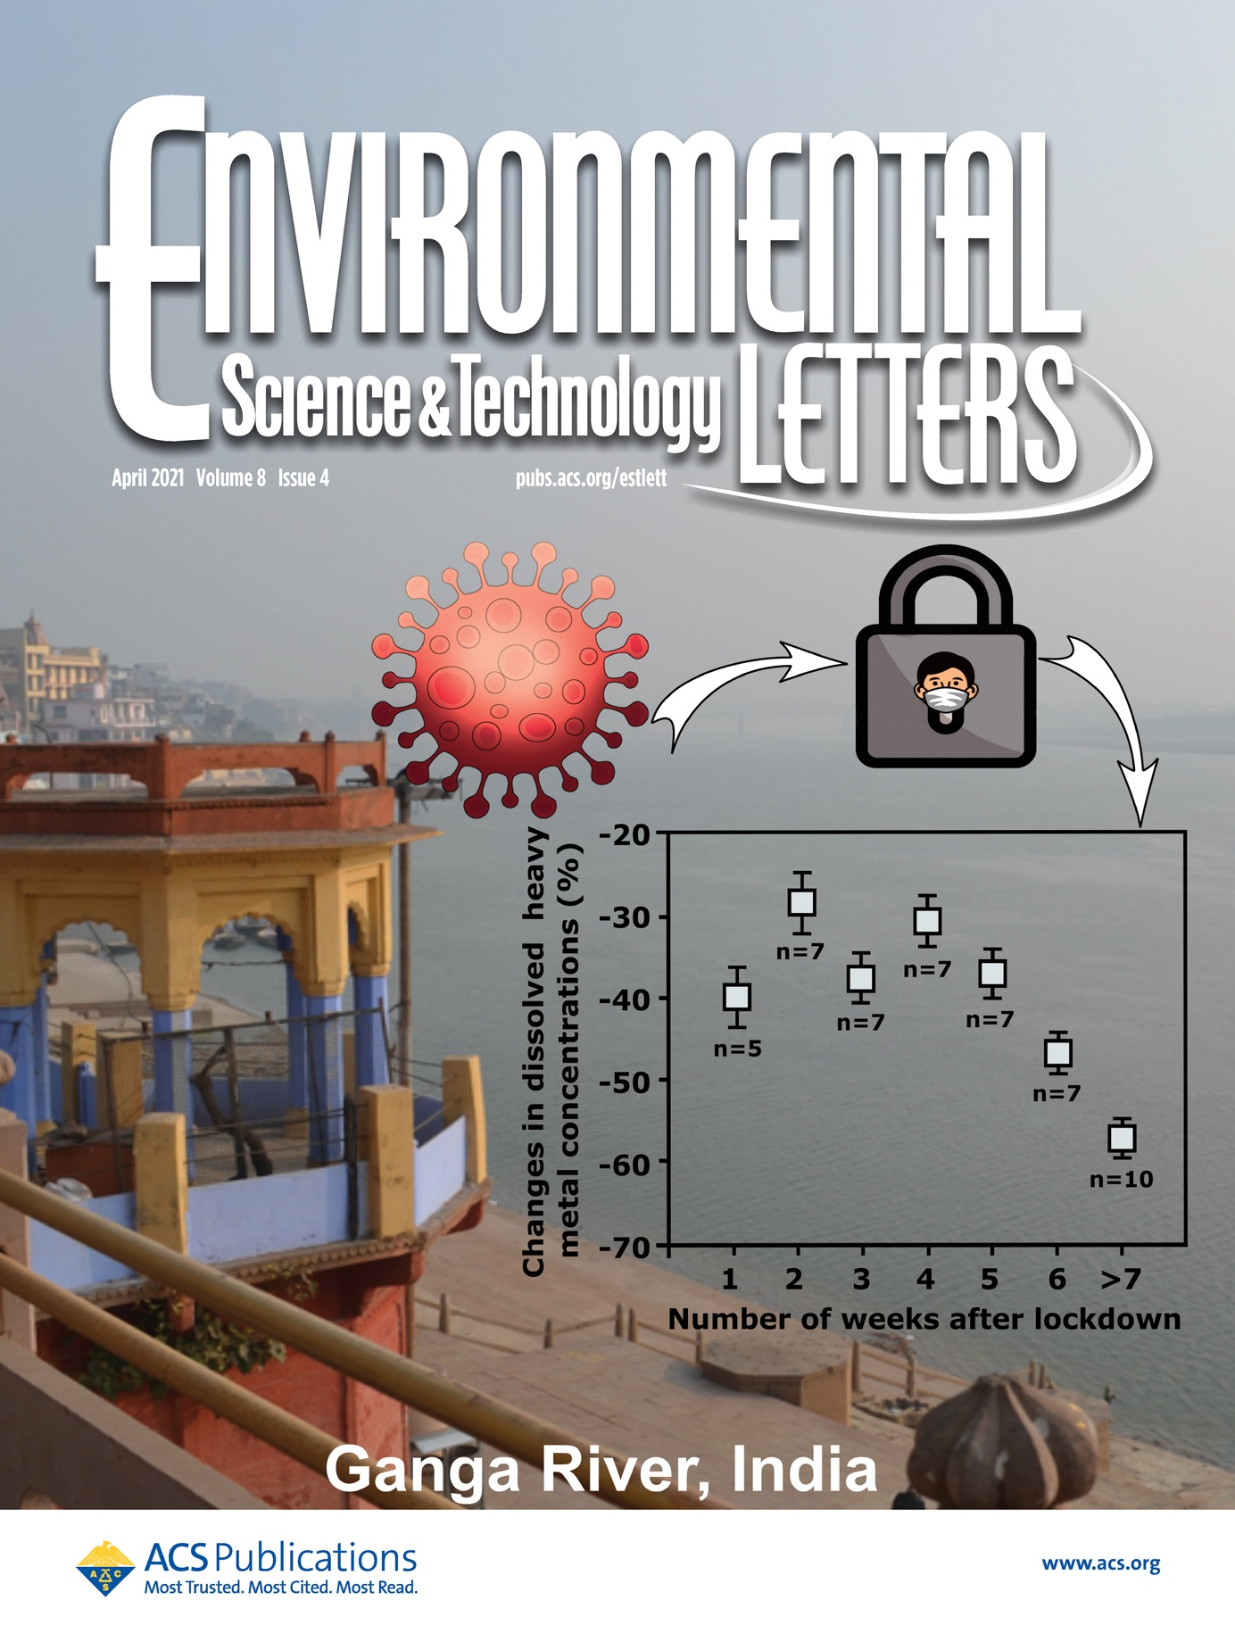

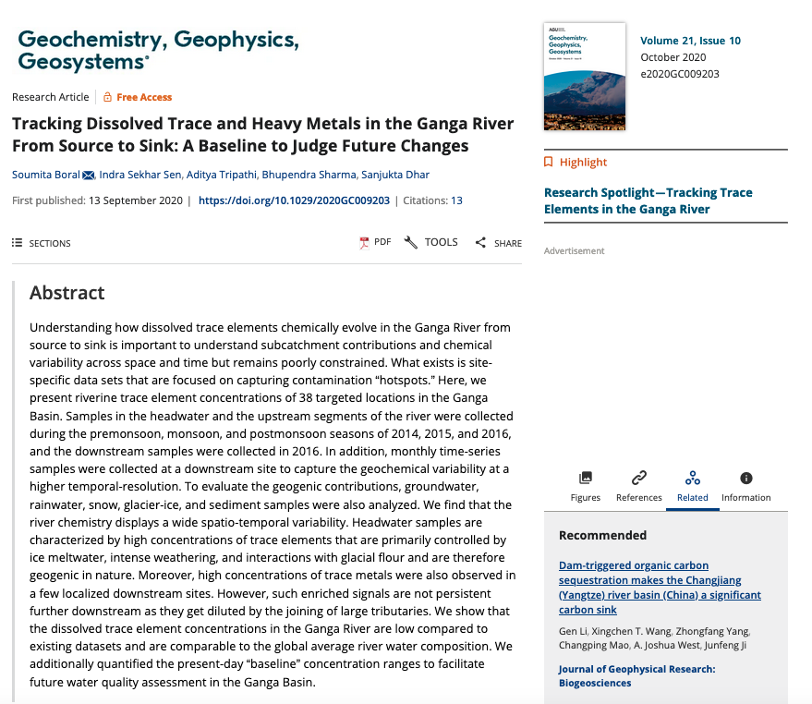

Translational Research

Our group aims to provide a cost-effective, scalable, and accessible solution to analyze and remove trace contaminants from water. We are developing technology that keeps communities safe from detrimental trace contaminants in drinking water by empowering them with actionable data and affordable solutions. We collaborate with researchers from MIT, USA and University of Waterloo, Canada for translational research

Some of the developed technology includes—

* Instantaneous water quality probe (IPI, Patent Number 360251, Date: 07.07.2020). The innovation created an easy-to-use colorimetric test-strip-based technology that analyzes 10 important water quality parameters in less than 2 minutes by combining digitization of colorimetric assays with ICP-MS/MS calibration curves. This innovation was selected for “74 Stories, 74 Years” by the Government of India and mentioned by the Hon’ble Prime Minister of India in “Mann Ki Baat” on August 16, 2020.

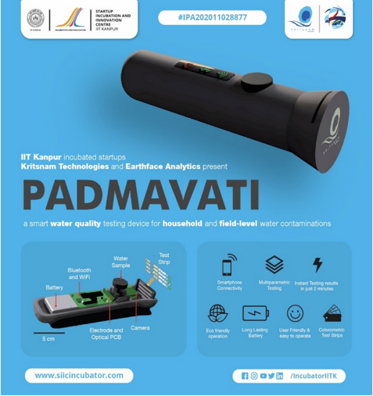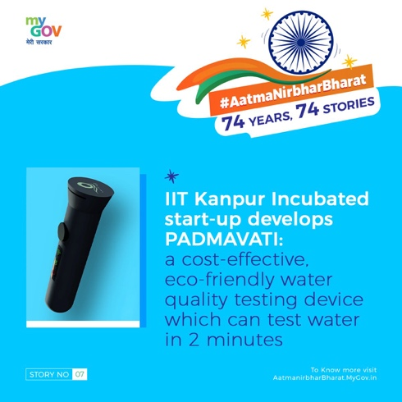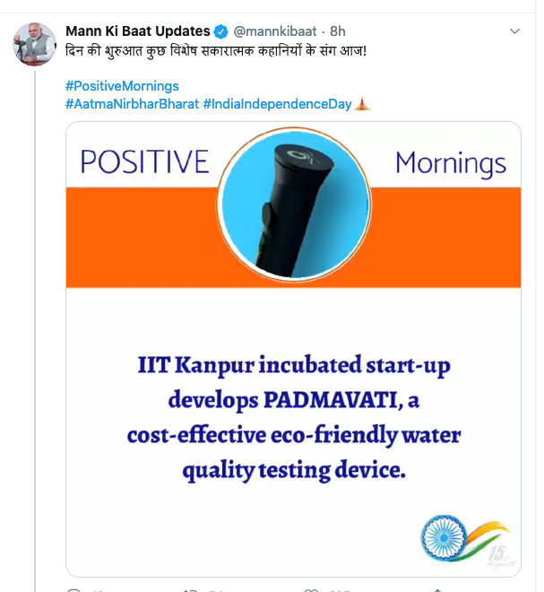

* A collapsible bottle filled with cation exchange resin that is capable of removing most of the common inorganic contaminants from water. The bottles can remove >95% of dissolved copper, nickel, lead, copper, and zinc, even in very hard water within 2-10 minutes (IPI, Patent Number 395528, Date 10.06.2020). The technology is based on the principle of cation-exchange processes in an aqueous system and provides a new paradigm for water quality monitoring by creating the sampling technology, materials, and system-level protocols to enable dry sample preservation of inorganic pollutants in water samples.

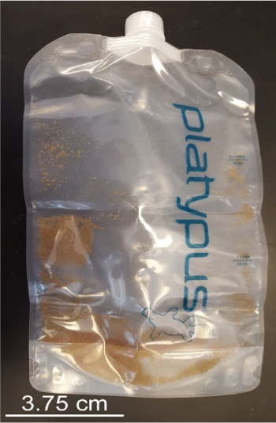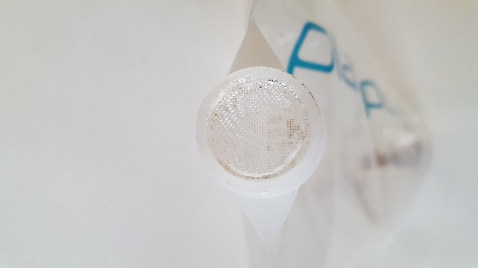



* An enzyme-substrate-based E. coli detection kit for drinking water (IPI, Patent Number 482960, Date of grant: 14.12.2023). The kit detects biomarkers secreted only by E. coli bacteria. The technology won the Innovation Challenge to develop a portable device for water quality testing by the Department of Promotion of Industry and Internal Trade, Government of India.

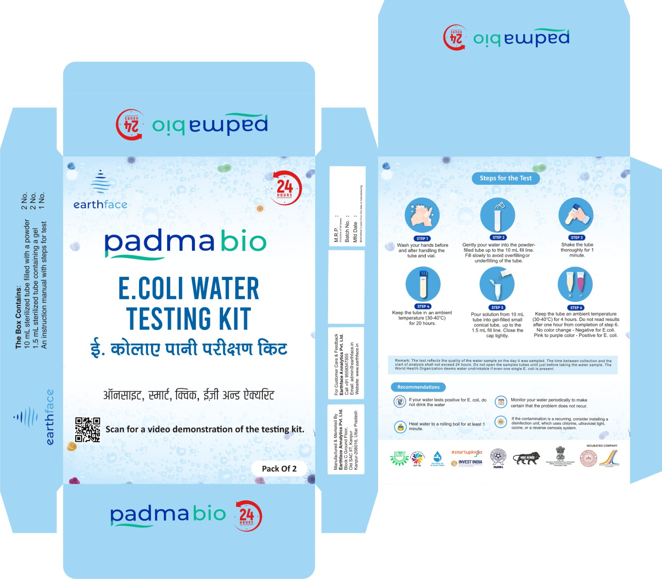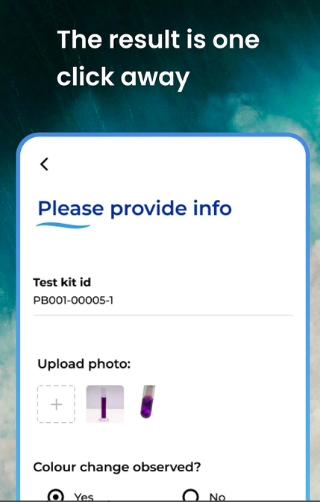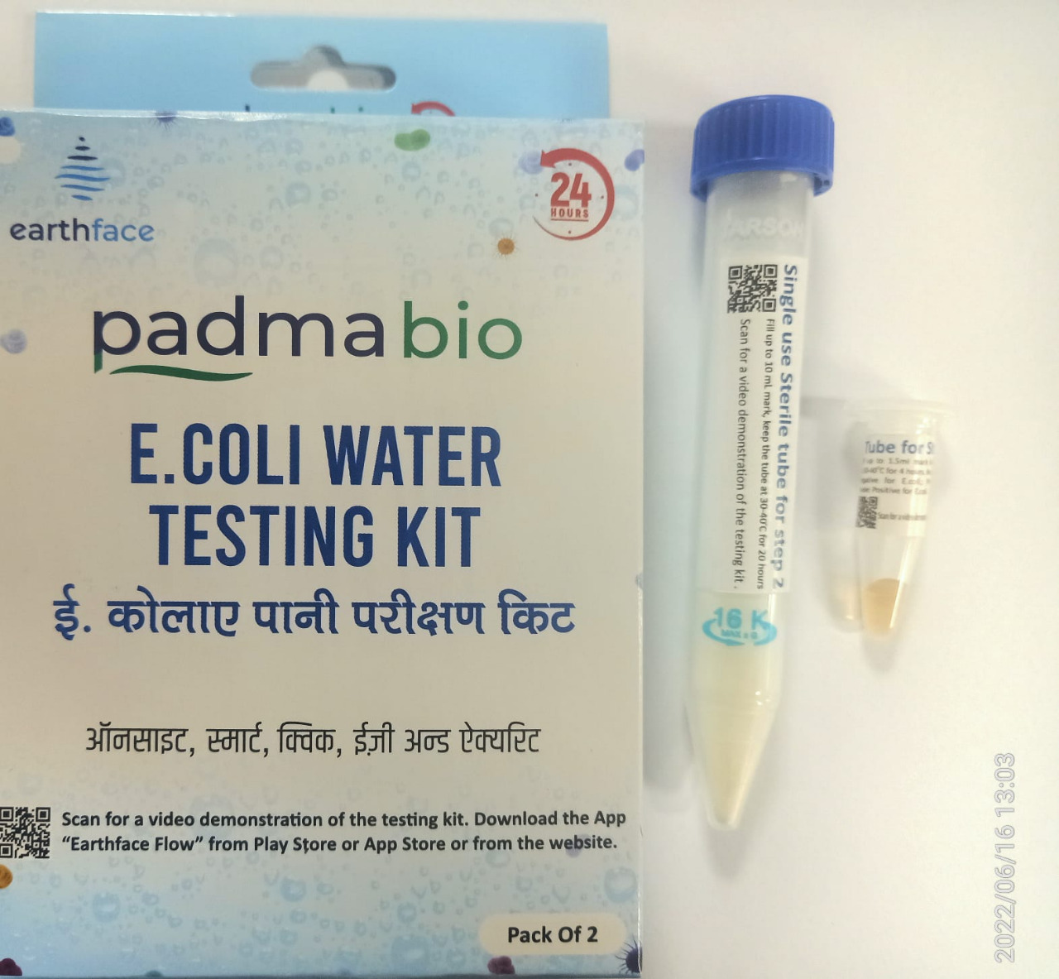

**

PEOPLE

## Principal Investigator

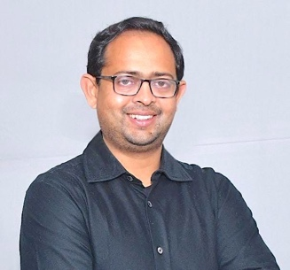 Indra Sen

2020 Associate Professor, Department of Earth Sciences and Centre for Environmental Science and Engineering, Indian Institute of Technology Kanpur, India

2021 Associate Editor, Vadose Zone Journal, Soil Science Society of America

2021 Associate Editor, Geophysical Research Letters, American Geophysical Union

2013 Postdoctoral Scholar/Investigator in Marine Chemistry and Geochemistry with [Dr. Bernhard Peucker-Ehrenbrink](https://www2.whoi.edu/staff/bpeucker/), Woods Hole Oceanographic Institution, USA

2010 Ph.D. in Geochemistry with [Prof. Gautam Sen](https://case.fiu.edu/earth-environment/opportunities/earth-and-environment-scholarships/sen-awards/), Florida International University, USA

## Staff Members

Lab Manager Aditya Tripathi

Office Administration: Bhupinder Sharma

## Post-Doctoral Associate

Dr. Richa Chaturvedi

https://scholar.google.com/citations?user=KgPlHD0AAAAJ&hl=en

**Ph.D - Scholar**

Samyak Pradhan

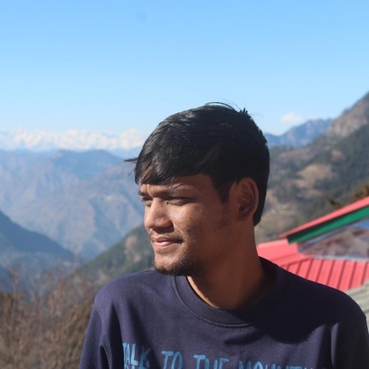

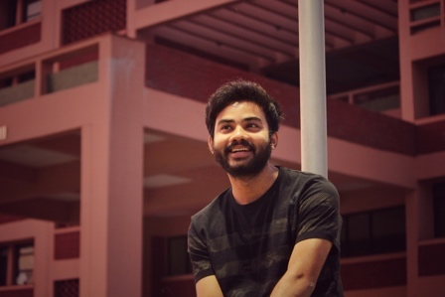 Subham Dutta

Lab Alumni

## Former Postdoctoral Researchers



2022-2023 Dr. Juzer Shaik (now Postdoctoral Fellow, University of Minnesota, USA

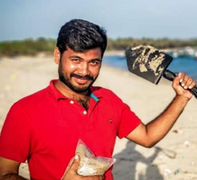

2021-2023: Dr. Neelavannan K. (now postdoctoral Research Fellow, KAUST, Saudi Arabia)

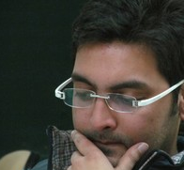2019-2022: Dr. Tanuj Shukla (now Associate Professor Research, Northwest Institute of Eco-Environment and Resources, Chinese Academy of Science, Lanzhou, China)

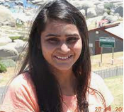

2017-2017: Dr. Mayuri Pandey (now Assistant Professor in Banaras Hindu University, India)

## Former Ph.D. Researchers

# 2017-2024: Mr. Shaifullah, Dissertation “A High-resolution Time Series River Chemistry Data from the Upper Ganga Basin: Temporal dynamics of Hydrogeochemical Processes”

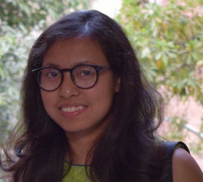

2018-2024: Ms. Nita Roy, Dissertation “Understanding monsoon controls on glacier melting, chemical weathering, and carbon cycle in the Himalayas” (On to postdoctoral fellow with Prof. Christoff Andermann, [University Rennes, CNRS, Géosciences Rennes, France](https://geosciences.univ-rennes.fr/))

## 2016-2021: Mr. Sarwar Nizam, Dissertation “Surface impurities in the Himalayan glaciers: Its sources, pathways, and spatial variation” (DST INSPIRE Faculty, on to [GFZ German Research Centre for Geosciences](https://www.gfz-potsdam.de/) as International Climate Protection Fellow, Humboldt Foundation

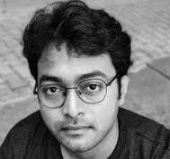

2015-2021: Mr. Arijeet Mitra, Dissertation “Tracing the cycling of PGE and Pb isotopes through the Earth's surface” (DST INSPIRE Faculty, Postdoctoral Research Scientist in the **N**ovel **I**sotopes in **C**limate, **E**nvironment and **R**ocks ([NICER Lab](https://nicerlab.ldeo.columbia.edu/)), Columbia University, USA

2015-2021: Ms. Soumita Boral, *Dissertation “*Isotopes and geochemical modelling to trace water sources and chemical dynamics of Himalayan Rivers from source to sink*” (*on to DST INSPIRE Faculty at the [Interdisciplinary Centre for Water Research (ICWaR),](https://icwar.iisc.ac.in) Indian Institute of Sciences, Bengaluru, India)

## Former Masters students (M.Tech.)

(10) 2020-2022: Mr. Anjan Halder, Spatio-temporal variability of silicate weathering and associated CO2  consumption in the Upper Ganga Basin

(9) 2019-2021: Mr. Tirthabasa Acharya, Occurrence, Source, and Spatial Distribution of Nitrate in Groundwaters of Ganga Basin

(8) 2019-2021: Mr. Subham Dutta, Geogenic Controls on the High Levels of Uranium in Alluvial Aquifers of the Ganga Basin

(7) 2018-2021: Ms. Ayushi Ram, Variations of major and trace elements along Ramganga basin in space and time

(6) 2018-2020: Mr. Haribansh Singh, Feasibility study of lead isotope analysis using ICP-QQQ MS/MS reaction cell

(5) 2016-2019: Ms. Nikitasha Chatterjee, Dissolved nutrients (nitrate, nitrite, phosphate and silicate) concentrations of the Ganga basin in space and time

(4) 2016-2018: Mr. Sarthak Ghosh, Lead isotopic fingerprinting of aerosols to characterize the sources of atmospheric lead in Woods Hole, USA

(3) 2015-2017: Ms. Gayatri Mishra, Major and trace element inputs to the Ganga River: Significance of small flood plain tributary as non-point pollution source

(2) 2014-2016: Mr. Sudhakar Ranjan, Nutrient fluxes from small floodplain rivers to large river systems: A case study in the Pandu River Basin

(1) 2014-2016: Mr. Sarwar Nizam, Effect of Southwest Monsoon withdrawal on airborne particles over the Indo-Gangetic Basin: Aerosol loading and heavy metal concentrations

PUBLICATIONS [three sections Publications/Patent/Conference Proceedings]

As displayed in IRIN

<https://iitk.irins.org/profile/52371#other_information_panel>

If that is not possible you can use the text here

## Peer-reviewed Articles

Web of Science Researcher ID: [S-4611-2019](https://publons.com/researcher/S-4611-2019/)

Scopus Author ID: [55346514800](https://www.scopus.com/authid/detail.uri?authorId=55346514800);

ORCID ID: <https://orcid.org/0000-0001-7302-2313>

Google Scholar Link: <https://scholar.google.com/citations?user=LXqfM3kAAAAJ&hl=en&oi=ao>

** Post-doc, **\***PhD student supervision, **‡** MTechstudent supervision, **‡‡** Undergraduatestudent supervision

**2024**

(43) Ansari, A., Sen, I.S., Sinha, R. Trends of water composition and discharge in the Ramganga River, Ganga Basin over the last forty years signal enhanced nitrate flux, **Journal of Hydrology *(****under review)*

(42) Pradhan, S. **\***, Sen, I.S., Metamorphic CO2 fluxes offset the geological carbon sink in the Himalayan-Tibetan orogen, **Earth and Planetary Science Letters *(****under review)*

(41) Roy, N*, Sen I.S., Boral, S., Shukla T., Velu, V. Isotope hydrograph separation reveals rainfall on the glaciers will enhance ice meltwater discharge to the Himalayan rivers (2023). **Water Resource Research** *(under review).*

(40) Shaifullah*, Sen I.S. A four-component mixing model reveals an early onset of snow meltwater runoff in the headwaters of River Ganga; (2024) **Journal of Hydrology**, 628, 130473https://doi.org/10.1016/j.jhydrol.2023.130473

**2023**

(39) Roy, N*, Sen I.S. CO2 consumption rates in the glacierized Himalayan headwaters: The importance of sulfuric and nitric acid-mediated chemical weathering reactions in geologic carbon cycle (2023). **Geochemistry, Geophysics, Geosystems**, 24, e2023GC010919, <https://doi.org/10.1029/2023GC010919>

(38) Shukla, T.,**  and Sen, I.S. Microplastics in freshwater ecosystems of India: Current trends and future perspectives (2023). **ACS Omega**, 2023, 8, 38, 34235–34248, <https://doi.org/10.1021/acsomega.3c01214>

(37) Neelavannan, K., ** Sen, I.S., Sinha,N., ThakurA. K., Misra, S. Microplastics in the Ganga-Brahmaputra delta: Sources and Pathways to the Sundarbans Biosphere Reserve-an UNESCO World Heritage Centre; (*2023*) **Environmental Advances**,11, 100350. <https://doi.org/10.1016/j.envadv.2023.100350>

(36) Shukla, T, ** Sen, I.S.; Sundriyal S., Carbon emissions from emerging glacier-fed Himalayan lakes, **Global and Planetary Changes,** Volume 225, June 2023, 104134<https://doi.org/10.1016/j.gloplacha.2023.104134>

(35)Cañedo-Argüelles, M., Brito, A.C., Sen, I.S., Roy, R. Editorial: Human Impacts on River Catchments and Coastal Ecosystems: A Meta-Ecosystem Perspective, **Frontiers in Marine Science**, 10, 2023, <https://doi.org/10.3389/fmars.2023.1168296>

(34) Shukla, S., **‡‡** Meshesha, T.W., Sen, I.S., Bol, R., Bogena, H., Wang, J. Assessing impacts of Land Use Land Cover (LULC) change on stream flow and runoff in Rurh Basin, Germany. **Sustainability** **2023**, 15(12), 9811; <https://doi.org/10.3390/su15129811>

(33) Sen I.S., Nizam S., Ansari A.;Bowes M., Choudhary B., Glendell M., Ray S., Scott M., Miller C., Wilkie C., Sinha R; eochemical evolution of dissolved trace elements in space and time in the Ramganga River, India; (2023) **Environmental Monitoring and Assessment, 1**95, 1150**,** [DOI:10.1007/s10661-023-11665-0](http://dx.doi.org/10.1007/s10661-023-11665-0)

**2022**

(32) Neelavannan K., **Achyuthan H., Sen I.S., Krishnakumar S., Gopinath K., Dhanalakshmi R., Rajalakshmi

P.R., Sajeev R., Distribution and characterization of plastic debris pollution along the Poompuhar Beach, Tamil Nadu, Southern India; (2022) **Marine Pollution Bulletin**, 175, [DOI:10.1016/j.marpolbul.2022.113337](http://dx.doi.org/10.1016/j.marpolbul.2022.113337)

(31) Nizam, S., ** Acharya, T., **‡** Sen, I.S., Dutta, S. ,**‡** Occurrence, Sources, Spatial Distribution of High Level of Fluoride and Associated Health Risks in Shallow Groundwater of Ganga Basin, India*; (2022)* **Environmental Geochemistry and Health***,* Jun 26. doi: 10.1007/s10653-022-01319-4

(30) Nizam, S., ** Virk, H.S., Sen, I.S. High levels of fluoride in groundwater from Northern parts of Indo-Gangetic Plains reveals detrimental fluorosis health risks; (2022) **Environmental Advances**, *8, 100200*

DOI: <https://doi.org/10.1016/j.envadv.2022.100200>

(29) Nizam S*., Dutta, S**‡**., Sen, I.S. Geogenic controls on the high levels of uranium in alluvial aquifers of the Ganga Basin; (2022) **Applied Geochemistry**, 143, 105374

(28) Neelavannan, S.**., Hussain, S.M., Sangode, S.J., Prakasam, M., Sen, I.S., Veerasingam, S., Tyagi, A., Kumar, P., Singh, P. A 51 Ka sedimentary sequence in a seamount basin, Eastern Arabian Sea: Records for palaeoceanographic and paleoclimatic conditions; (2022) **Journal of Asian Earth Sciences**, 226, 105086, [DOI:10.1016/j.jseaes.2022.105086](http://dx.doi.org/10.1016/j.jseaes.2022.105086)

(27) Neelavannan, K.,** Sen, I.S., Lone, A.M., Gopinath, K. Microplastics in the high-altitude Himalayas: Assessment of microplastic contamination in freshwater lake sediments, Northwest Himalaya, India;(2022) **Chemosphere**, 290, art. no. 133354.

DOI: 10.1016/j.chemosphere.2021.133354

(26) Nizam, S.,** Mitra, A., Shukla, S., Misra, S., Sen, I.S. Time-Series Record of Ambient Platinum Group Elements over a Remote Himalayan Station: Insights over the Baseline Estimate to Judge Future Changes;(2022) **Water, Air, and Soil Pollution**, 233 (1), art. no. 10.

DOI: 10.1007/s11270-021-05478-5

**2021**

(25) Shukla, T.,** Sen, I.S. Preparing for Floods on the Third Pole; (2021) **Science**, 372 (6539), pp. 232-234.

DOI: 10.1126/science.abh3558

(24) Shukla, T.,** Sen, I.S., Boral, S.,**\*** Sharma, S. A Time-Series Record during COVID-19 Lockdown Shows the High Resilience of Dissolved Heavy Metals in the Ganga River; (2021) **Environmental Science and Technology Letters**, 8 (4), pp. 301-306.

DOI: 10.1021/acs.estlett.0c00982

(23) Nizam, S.,**\*** Sen, I.S., Shukla, T.,** Selby, D. [Melting of the Chhota Shigri Glacier, Western Himalaya, Insensitive to Anthropogenic Emission Residues: Insights from Geochemical Evidence; (2021) **Geophysical Research Letters**, 48 (19), art. no. e2021GL092801.

DOI: 10.1029/2021GL092801

(22) Mitra, A.,**\*** Sen, I.S., Pandey, S.K., Velu, V., Reisberg, L., Bizimis, M., Cloquet, C., Nizam, S.**\*** Lead Isotope Evidence for Enhanced Anthropogenic Particle Transport to the Himalayas during Summer Months; (2021) **Environmental Science and Technology**, 55 (20), pp. 13697-13708.

DOI: 10.1021/acs.est.1c03830

(21) Boral, S.,**\*** Peucker-Ehrenbrink, B., Hemingway, J.D., Sen, I.S., Galy, V., Fiske, G.J. Controls on Short-Term Dissolved 87Sr/86Sr Variations in Large Rivers: Evidence from the Ganga–Brahmaputra; (2021) **Earth and Planetary Science Letters**, 566, art. no. 116958.

DOI: 10.1016/j.epsl.2021.116958

(20) Mitra, A.,**\*** Sen, I.S., Walkner, C., Meisel, T.C. Simultaneous Determination of Platinum Group Elements and Rhenium Mass Fractions in Road Dust Samples using Isotope Dilution Inductively Coupled Plasma-Tandem Mass Spectrometry after Cation Exchange Separation; (2021) **Spectrochimica Acta - Part B Atomic Spectroscopy**, 177, art. no. 106052.

DOI: 10.1016/j.sab.2020.106052

**2020**

(19) Boral, S.,**\*** Sen, I.S. Tracing 'Third Pole' Ice Meltwater Contribution to the Himalayan Rivers using Oxygen and Hydrogen Isotopes; (2020) **Geochemical Perspectives Letters**, 13, pp. 48-53.

DOI: 10.7185/geochemlet.2013

(18) Nizam, S., **\*** Sen, I.S., Vinoj, V., Galy, V., Selby, D., Azam, M.F., Pandey, S.K., Creaser, R.A., Agarwal, A.K., Singh, A.P., Bizimis, M. Biomass-Derived Provenance Dominates Glacial Surface Organic Carbon in the Western Himalaya; (2020) **Environmental Science and Technology**, 54 (14), pp. 8612-8621.

DOI: 10.1021/acs.est.0c02710

(17) Shukla, T.,** Sundriyal, S., Sen, I.S. Contemporary Inorganic Carbon Fluxes from Rapidly Changing Glacierized Watersheds of the Himalaya; (2020) **Journal of Hydrology**, 587, art. no. 124972.

DOI: 10.1016/j.jhydrol.2020.124972

(16) Boral, S.,**\*** Sen, I.S., Tripathi, A., Sharma, B., Dhar, S. Tracking Dissolved Trace and Heavy Metals in the Ganga River from Source to Sink: A Baseline to Judge Future Changes; (2020) **Geochemistry, Geophysics, Geosystems**, 21 (10), art. no. e2020GC009203.

DOI: 10.1029/2020GC009203

**2019**

(15) Boral, S.,**\*** Sen, I.S., Ghosal, D., Peucker-Ehrenbrink, B., Hemingway, J.D. Stable Water Isotope Modeling Reveals Spatio-Temporal Variability of Glacier Meltwater Contributions to Ganges River headwaters; (2019) **Journal of Hydrology**, 577, art. no. 123983.

DOI: 10.1016/j.jhydrol.2019.123983

(14) Hemingway, J.D., Spencer, R.G.M., Podgorski, D.C., Zito, P., Sen, I.S., Galy, V.V. Glacier Meltwater and Monsoon Precipitation Drive Upper Ganges Basin Dissolved Organic Matter Composition; (2019) **Geochimica et Cosmochimica Acta**, 244, pp. 216-228.

DOI: 10.1016/j.gca.2018.10.012

(13) Wu, F., Owens, J.D., Huang, T., Sarafian, A., Huang, K.-F., Sen, I.S., Horner, T.J., Blusztajn, J., Morton, P., Nielsen, S.G. Vanadium isotope composition of seawater; (2019) **Geochimica et Cosmochimica Acta**, 244, pp. 403-415. DOI: 10.1016/j.gca.2018.10.010

**2018**

(12) Sen, I.S., Boral, S.,**\*** Ranjan, S.,**‡** Tandon, S.K. Small but Important: The Role of Small Floodplain Tributaries to River Nutrient Budgets; (2018) **ACS Earth and Space Chemistry**, 2 (1), pp. 64-71.

DOI: 10.1021/acsearthspacechem.7b00112

(11) Nizam, S.,**‡** Sen, I.S. Effect of Southwest Monsoon Withdrawal on Mass Loading and Chemical Characteristics of Aerosols in an Urban City over the Indo-Gangetic Basin; (2018) **ACS Earth and Space Chemistry**, 2 (4), pp. 347-355. DOI: 10.1021/acsearthspacechem.7b00140

**2017**

(10) Mitra, A.,**\*** Sen, I.S. Anthrobiogeochemical Platinum, Palladium and Rhodium Cycles of Earth: Emerging Environmental Contamination; (2017) **Geochimica et Cosmochimica Acta**, 216, pp. 417-432.

DOI: 10.1016/j.gca.2017.08.025

**2016**

(9) Sen, G., Hames, W.E., Paul, D.K., Biswas, S.K., Ray, A., **Sen, I.S**. Pre-Deccan and Deccan Magmatism in Kutch, India: Implications of New 40Ar/39Ar Ages of Intrusions; (2016) **Journal of Geological Society of India**, 6*.* **DOI:** [10.17491/cgsi/2016/105422](http://dx.doi.org/10.17491/cgsi%2F2016%2F105422)

(8) Sen, I.S., Bizimis, M., Tripathi, S.N., Paul, D. Lead Isotopic Fingerprinting of Aerosols to Characterize the Sources of Atmospheric Lead in an Industrial City of India; (2016) **Atmospheric Environment**, 129, pp. 27-33. DOI: 10.1016/j.atmosenv.2016.01.005

(7) Sen, I.S., Mitra, A.,**\*** Peucker-Ehrenbrink, B., Rothenberg, S.E., Tripathi, S.N., Bizimis, M. Emerging airborne contaminants in India: Platinum Group Elements from Catalytic Converters in Motor Vehicles; (2016) **Applied Geochemistry**, 75, pp. 100-106.

DOI: 10.1016/j.apgeochem.2016.10.006

**2015—2010**

(6) Sen, I.S., Peucker-Ehrenbrink, B. Determination of Osmium Concentrations and 187Os/188Os of Crude Oils and Source Rocks by Coupling High-Pressure, High-Temperature Digestion with Sparging OsO4 into a Multicollector Inductively Coupled Plasma Mass Spectrometer; (2014) **Analytical Chemistry**, 86 (6), pp. 2982-2988.

DOI: 10.1021/ac403413y

(5) Sen, I.S. Platinum Group Element Pollution is a Growing Concern in Countries with Developing Economy; (2013) **Environmental Science and Technology**, 47 (24), pp. 13903-13904.

DOI: 10.1021/es404890e

(4) Sen, I.S., Peucker-Ehrenbrink, B., Geboy, N. Complex Anthropogenic Sources of Platinum Group Elements in Aerosols on Cape Cod, USA;(2013) **Environmental Science and Technology**, 47 (18), pp. 10188-10196.

DOI: 10.1021/es4016348

(3) Sen, I.S., Peucker-Ehrenbrink, B. Anthropogenic Disturbance of Element Cycles at the Earth's Surface

(2012) **Environmental Science and Technology**, 46 (16), pp. 8601-8609.

DOI: 10.1021/es301261x

(2) Sen, I.S., Bizimis, M., Sen, G., Huang, S. A radiogenic Os Component in the Oceanic Lithosphere? Constraints from Hawaiian Pyroxenite Xenoliths;(2011) **Geochimica et Cosmochimica Acta**, 75 (17), pp. 4899-4916.

DOI: 10.1016/j.gca.2011.06.008

1. Sen, I.S., Bizimis, M., Sen, G. Geochemistry of Sulfides in Hawaiian Garnet Pyroxenite Xenoliths: Implications for Highly Siderophile Elements in the Oceanic Mantle; (2010) **Chemical Geology**, 273 (3-4), pp. 180-192.

DOI: 10.1016/j.chemgeo.2010.02.021

## Patent

(3) Sen, I.S., Dasgupta, A., Sen, Soumya., Karnik, Rohit. A low cost to detect E. coli. in water and method thereof (Indian Patent Application Number 202211034165, Date of filing: 15.06.2022; Patent Number 482960, Date of Grant: 14/12/2023)

(2) Choudhary, B., ** Pal, S., Harsha, K., Saxena, S., Sen, I.S., Liquid quality measurement system (Indian Patent Application Number 202011028877, Date of filing: 07.07.2020, Patent Number 360251, Date of Grant: 04/03/2021)

(1) Sen, I.S., Harsha, K., Hanhauser, E.B., Karnick, R.N., Hart, A.J., Bono, M, Vaishnav C.H., A Vessel and A Method for Purifying Water and Monitoring Quality of Water (Indian Patent Application Number 202011024458, Date of filing: 10.06.2020, Patent Number 395528, Date of Grant: 27/04/2022)

## Conference Proceedings

* Ph.D. student supervision, **‡** MTechstudent supervision

(C39) Neelavannan, K., ** Sen, I.S., Sinha,N., ThakurA. K., Misra, S Microplastics in the Ganga River: Sources and Pathways to the Sundarbans Biosphere Reserve, poster number 14295, Goldschmidt Conference, Lyon, France, 2023

(C38) Shaifullah*, Sen I.S Seasonal trends of chemical weathering rate and CO2 consumption yield in the Upper Ganga Basin, poster number 14297, Goldschmidt Conference, Lyon, France, 2023

(C37) Roy, N*, Sen I.S., Strong and weak mineral acid-mediated chemical weathering pathways in the Central Himalayas: Its role on the chemical weathering and CO2 consumption rates, poster number 13816, Goldschmidt Conference, Lyon, France, 2023

(C36) Pradhan, S.*, Sen Quantifying the role of deep carbon fluxes on the geological carbon budgets of orogenic belts, poster number 14001, Goldschmidt Conference, Lyon, France, 2023

(C35) Shaifullah*, Sen I.S. Stable water isotope modeling reveals early onset of snowpack melting in the headwaters of the Ganga River, Frontiers in Geosciences Research Conference 2023, PRL Ahmedabad

(C34) Pradhan, S.*, Sen, “Carbon and Helium Isotopes to Address Himalayan Metamorphic CO2 fluxes to the Atmosphere.”: Frontiers in Geosciences Conference, 2023

(C33) Pradhan, S.*, Sen, I.S., Shukla. T**., and Nizam, S.**, “The Magnitude and Implications of Atmospheric CO2 Released by Metamorphic Processes in the Himalayan-Tibetan Orogen.”: AGU Fall Meeting, 2022

(C32) Shaifullah*, Sen I.S. Isotope hydrograph separation reveals an early onset of snow meltwater in the Himalayas, AGU Fall Meeting 2022, Chicago, 12-16 December

(C31) Roy, N*, Sen I.S., Boral, S., Shukla T., Velu, V. Evidence of Rain Induced Melting in the Upper Ganga basin, AGU Fall Meeting 2022, Chicago, 12-16 Dec.

(C30) Boral S*, Sen I.S. Tracing dissolved trace elements from source to sink: Spatio-temporal variability and baseline concentrations in Ganges to judge future changes. Goldschmidt Abstracts, 2020**,** 224

(C29) Shukla T**, Sen I.S. The control of hydrological inorganic carbon input on plaeo-CO2 release from glacial lakes, Goldschmidt Abstracts, **2020** 2376

(C28) Mitra A *, Sen I.S, Meisel T, Walkner C. Platinum Group Elements in Indian Environment: Magnitude and Pathways, Goldschmidt Abstracts, **2020**, 1816

(C27) Mitra, A., * Sen, I.S., Vinoj V., Pandey, S.K., Planetary boundary layer height controls the transport of heavy metals to the Himalayan Glaciers, Accepted for oral presentation in Goldschmidt, 2020.

(C26) Boral, S., * Peucker-Ehrenbrink, B., Hemmingway, J.D., Sen, I.S., Galy, V. Controls on temporal variations in the dissolved 87Sr/86Sr of large rivers: Evidence from the Ganga and Brahmaputra. Goldschmidt Abstracts 2019, 334 (Oral Presentation).

(C25) Nizam S, * Sen IS, Galy V, Selby D, Vinoj V, Bizmis M & Azam MF. Biomass derived carbon key to western Himalayan Glacier melt. *Goldschmidt 2019, 09c/385/Mo*.

(C24) Chandra J., Paul D., Sen I.S., Ansari A.J., Uniyal A. Osmium isotopic composition of carbonatites and associated rocks from the Amba Dongar carbonatite complex, Gujrat reveals presence of old oceanic crust in the source. American Geophysical Union, Fall Meeting 2019, abstract #V11E-0128

(C23) Mitra, A.,* Sen, I.S., Meisel, T., Integration of air mass trajectory models and Pb isotope data to trace the long-range transport of atmospheric dust in India. Goldschmidt Abstracts 2018, 1783

(C22) Nizam, S.,* Sen, I.S., Azam M.F., Selby, D., Geochemical characteristics of cryoconite holes on Chota Shingri glacier, Western Himalaya, India. *Goldschmidt 2018, 08i/235/Th*.

(C21) Gupta, S., Tripathi, S., Sinha R., Karumanachi, S.K., Paul, D., Tripathi, S.N., Sen, I.S.,Setting up a new CZO in the Ganga basin: Instrumentation, stakeholder engagement and preliminary observations, Abstract H41G-1535 presented at 2017 Fall Meeting, AGU, New Orleans, Louisiana. 11-15 Dec

(C20) Sen, I.S., Laxmi, V., Mishra G. ‡,Major and trace element fluxes to the Ganges River: Significance of small flood plain tributary as non-point pollution source, Abstract EP21D-1869 presented at 2017 Fall Meeting, AGU, New Orleans, Louisiana. 11-15 Dec

(C19) *Sen, I.S., Boral, S., * Ranjan, S., Tandon, S. Nutrient Transport by Small Floodplain Rivers: Their Importance and Contribution to Land-to-Ocean Fluxes. Goldschmidt Abstracts, 2017 3591.

(C18) Nizam, S. ‡,Sen, I.S. Physical and chemical interactions between the southwest monsoon rains and aerosols over the Indo-Gangetic Basin, *Goldschmidt 2017, 3068, 16e/368/Th.*

(C17) Boral, S.*, Sen, I.S., D., Ghoshal., Sinha, R., Peucker-Ehrenbrink, B., Hemmingway, J.D. Relationship between Indian summer monsoon and melting Himalayan glaciers. Goldschmidt Abstracts, 2017 397 (Oral Presentation).

(C16) Mitra, A., * Sen, I.S., Peucker-Ehrenbrink, B., Rothenberg, S., Tripathi, S.N., Bizimis, M., Emerging airborne contaminants in India: Platinum group of elements from catalytic convertors in motor vehicles, 4th Highly siderophile element geochemistry workshop, Durham, U.K., 2016

(C15) Nizam, S., ‡ Sen, I.S., V. Vinoj, Aerosol loading during waning phase of Indian summer monsoon over the Indo-Gangetic Basin: PM10 levels and heavy metal concentrations National Symposium on Tropical Meteorology (TROPMET) on Climate Change and Coastal Vulnerability, 2016

(C14) Boral, S., * Sen, I.S., Sinha, R., Peucker-Ehrenbrink, B., Ghosal, D. Hydrological dependence of Ganges river on Himalayan cryosphere, Goldschmidt Abstracts, 2016 268.

(C13) Boral, S.*, Sen, I.S., Sinha, R., Peucker-Ehrenbrink, B. Hydrological Dependence of River Ganga on Himalayan Cryosphere. TWAS ROCASA Conference, IISC Bangalore, India 2016 (invited, poster).

(C12) Huang, T., Owens, J., Sarafin, A., Sen, I.S., Huang, K-F., Blusztajn, J., Nielsen, S. Development of analytical techniques of vanadium isotope in seawater, AGU Fall Meet. Abstract PP31B-2233, 2015

(C11) Sen, I.S., Bizimis, M., Tripathy, S.N., Paul, D., Tyagi, S., Sengupta, D. Lead isotopes and trace metal ratios of aerosols as tracers of Pb pollution sources in Kanpur, India, Geophysical Research Abstracts, Vol. 17, EGU 2015-14042, Vienna, Austria, 2015

(C10) Sen, I.S., Hemingway, Sengupta, D., Sinha, R., Peucker-Ehrenbrink, B., Chakraborty, A. Seasonal variation of glacial melt proportion in the headwaters of the Ganges River: Preliminary results, Geophysical Research Abstracts, Vol. 17, EGU 2015-5125, Vienna, Austria 2015

(C9) Peucker-Ehrenbrink B., Sen I.S., Geboy N. Anthropogenic osmium in airborne particles from Woods Hole, Massachusetts, Abstract V23E-2893, presented at 2012 Fall meeting, **AGU, San Francisco, Calif., 3-7 Dec**

(C8) Sen I.S. and Peucker-Ehrenbrink B. Human impact on global element cycles, **Geochimica et Cosmochimica Acta 2011, 75(3), A1837**

(C7) Sanchez-hernandez Y., Maurrasse, F.J., Sen I.S., Moreno-Bedmar J.A. The Cabó section, Sierra de Prada, south central Pyrénnées, NE Spain: relation to Early Aptian oceanic oxygen conditions, Abstract PP21C-1808 presented at 2011 Fall Meeting, AGU, San Francisco, Calif., 5-9 Dec.

(C6) Gionfriddo, C.; Bizimis, M.; Sen, I.S.; Salters, V., Chalcophile elements in peridotites as a proxy for sulfide mineralization during serpentinization. Geochimica et Cosmochimica Acta 2010, 74 (12) Suppl. 1, A334

(C5) Sen I.S., Bizimis M., Huang S., Sen G. Origin of sulfides and pyroxenites in the Hawaiian mantle: Insights from PGE and Os isotopes, **Geochimica et Cosmochimica Acta 2010, 74 (11), Suppl. 1, A933**

(C4) Sen, I. S.; Luo, H.; Hall, J. S., Linking Migration with Fluid Mixing – A Case Study from Plutonio Field, Block 18, Angola, . Technology Fair, British Petroleum, Houston, Tx, 2009

(C3) Sen I.S., Bizimis M., Huang S., Sen G. Re-Os Isotope Systematics and PGE Abundances in Garnet Pyroxenite Xenoliths from Oahu, Hawaii: Implications on Melt-Peridotite Reaction in the Oceanic Mantle, Eos Trans. AGU 2008, 89(53), Fall Meet. Suppl., Abstract V43B-2160

(C2) Sen I.S., Bizimis M., Sen G. Platinum Group Element Abundances in the Hawaiian Mantle: Constraints from in-Situ Sulfide and Bulk Rock Analyses of Garnet Pyroxenite Xenoliths from Oahu, Joint Annual Meeting -Geological Society of America 2008, 141-13

(C1) Sen I.S., Sen G., Bizimis M. Sulfides in the Garnet Pyroxenite Xenoliths from Oahu, Hawaii, Eos Trans. AGU 2007, 88(52), Fall Meet. Suppl, Abstract DI33A-1126

FACILITIES

Embed the video

https://www.youtube.com/watch?v=6EZhK2qrwRc

Lab Pictures will be shared

## A metal-free clean laboratory was developed to provide optimal conditions for the separation and purification of isotopes for mass spectrometry. The laboratory consists of three isolated rooms. Some of the major equipment in our lab includes Agilent® 8900 ICP-MS/MS, Piccaro **G2201-i Isotopic Analyzer (**δ13C for CH4 and CO2), Continuous Flow Auto Analyzer from SEAL Analytical, UV/VIS Spectrophotometer from Agilent®, and High-Pressure Asher (HPA-S) from Anton Paar. We have state-of-the-art HEPA-filtered air ductless chemical work station (600 series) from AirClean System, acid evaporation system from Analab, polypropylene laminar flow fume hoods from NUAIRE and Nano Clean, sub-boiling distillation devices from PicoTrace (Cupola Distillation) and Savilex for purification of acids, and high precision balances from Mettler Toledo. Recently,

**TEACHING TAB**

Some of the courses that I am teaching regularly in IIT Kanpur includes—

**Geochemistry (ES413)**

Internal structure of atoms, electronic structure, chemical bonding, and chemical properties of elements. Fundamentals of Thermodynamics and its application in Earth Sciences. Aquatic geochemistry, primary silicates and chemical weathering, acids and bases, dissolution and precipitation reactions, mineral stability diagrams, Eh-pH diagrams, oxidation-reduction reactions. The origin and evolution of Earth and the solar system through high temperature chemical processes, trace elements in igneous processes, modeling trace element partition during magma genesis. Radiogenic isotope geology and geochronology. Stable isotope geochemistry. Earth’s hydrosphere and its interaction with surficial rocks, sediments, soils, biosphere and the atmosphere.

**Aqueous Geochemistry (ES 643)**

Water Cycle/Earth’s Surface Processes/Rivers and Oceans, thermodynamics, solutions and equilibrium constant, Kinetics, Acid and Bases/Salts/Mineral Stability Diagrams, General Controls of Natural Water Chemistry, Water Isotopes-Understanding Water Evolution, Water Characterization Techniques, Aqueous Geochemistry and Ore Deposits, Aqueous Geochemistry of Acid Mine Drainage, Geochemical Cycling of Redox Sensitive Trace Metals, Chemical Weathering, Atmospheric CO2 and Climate, Contaminant Geochemistry (Focus on Arsenic)

**Isotope Geochemistry & Applications (ES 649)**

Atoms and nuclei, Decay systems and Geochronology, Radiogenic isotope geochemistry of the mantle, Radiogenic isotopic geochemistry of the continental crust and ocean, Radiogenic isotopic geochemistry to track surface processes, Stable isotope geochemistry, Stable isotope geochemistry and its application, Unconventional isotopes and approaches, Mass Spectrometry and lab practices

**Fundamentals of Earth Sciences (ESO-213)**

Solar System and Earth; The primitive Earth; Geological Time scale; Origin of life and major geological events; Numerical Dating. Rocks, minerals and soils; Plate Tectonics and Mountain building; Deformation and Geodynamics; Earthquakes, Volcanoes. Earth, Ocean, Land, Rivers, Atmosphere, Biosphere, Cryosphere and Climate; Energy budget; Carbon Cycle; Hydrological Cycle; Weathering and erosion. Coupled processes in Earth System; climate change, Geological resource (minerals, hydrocarbons and water); Sustainability and Anthropocene activities.

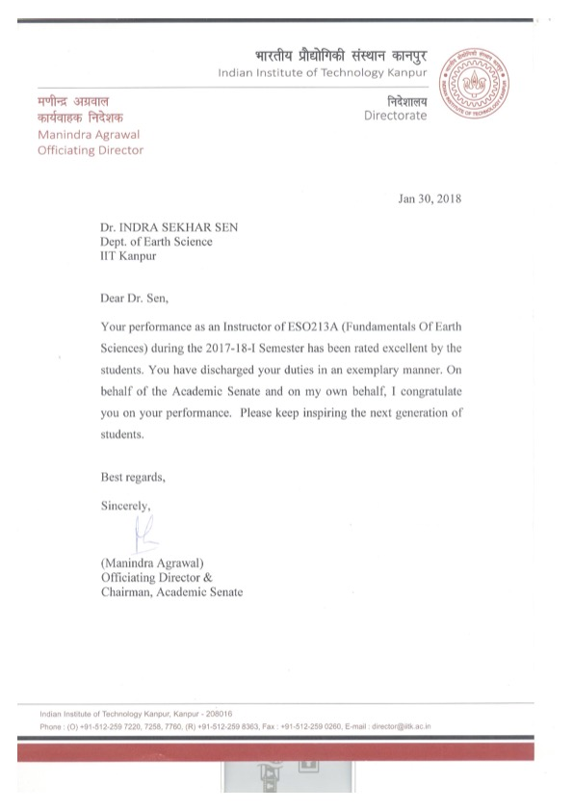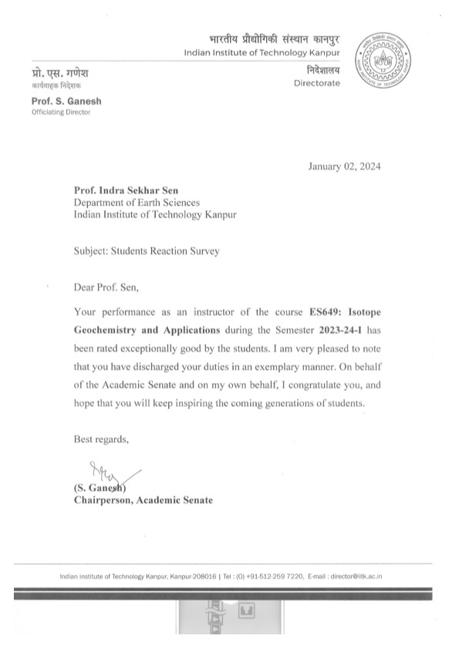

Invited Research Talks

07-2023 The geochemical perspective of the drivers and impacts of melting Himalayan glaciers, **GFZ, Potsdam, Germany**

06-2023 Tracking the glacier meltwater of “Third Pole” fed rivers in space and time using isotopic tracers, **Institute of Environmental Assessment and Water Research (IDAEA-CSIC), Barcelona, Spain**

06-2023 The drivers and impact of melting Himalayan glaciers, **ETH Zurich, Switzerland**

03-2021 Surface impurities in the Himalayan glaciers: Its sources, pathways, and spatial variation, **Indian Institute of Science Education and Research Pune** (online due to COVID-19 pandemic), **India**

02-2021 New paradigms in water quality monitoring, **National Water Mission, Ministry of Jal Shakti, Government of India** (online due to COVID-19 pandemic)

08-2020 Surface impurities in the Himalayan glaciers: Its sources, pathways, and spatial variation, **Ministry of Earth Sciences, Government of India** (online due to COVID-19 pandemic)

08-2020 Study of emerging contaminants contributed by PGEs rich particulates from vehicular emission using the ICP-MS/MS technique, **Agilent Technologies** (online due to COVID-19 pandemic), **India**

12-2019 Source and Transport Pathways of Surface Impurities to the Himalayan Glaciers: A Coupled Organic-Inorganic Perspective. **University of Leoben, Austria**

04-2018 Underestimated Glacier Mass Loss in “The Third Pole” and its Contribution to Global Sea-Level Rise**, Environmental Science & Technology Symposium-India**

03-2018 The drivers of deglaciation in the Himalayas and its impact on global sea level rise**, University of South Carolina, Columbia, USA**

10-2017 The Third Pole: Frozen water in the Himalayas**, Columbia/Snake River Expedition, Portland, USA**

03-2016 Will the rivers run dry? Global River Observatory Meeting, onboard cruise vessel **Mekong Sun, Thailand**

02-2014 Earth System Sciences, **Indian Institute of Science Education and Research, Bhopal**,

India [Outreach Activity]

12-2013 Elemental Journey: Humans have changed how chemicals move on Earth’s surface, **Indian Institute of Technology-Gandhinagar, India**

09-2013 Tracing Earth system processes: From petroleum systems to aerosols, **Indian Institute**

**of Technology-Kanpur, India**

10-2013 Osmium and Vanadium isotopes as tracers of Earth system processes, **Indian Institute of Science Education and Research, Kolkata, India**

08-2013 Osmium and Vanadium isotopes as tracers of Earth system processes, **Indian Institute**

**of Science, Bangalore, India**

08-2013 Osmium and Vanadium isotopes as tracers of Earth system processes, **Indian Institute**

**of Technology Kharagpur, India**

04-2013 Humans have changed how chemicals move on Earth’s surface, **Indian Institute of Technology Bhubaneswar, India**

11-2011 Platinum Group Elements and osmium isotope geochemistry: A tale from Earth’s mantle to the atmosphere, **Indian Institute of Science Education and Research, Kolkata, India**

01-2011 A radiogenic Os component in the oceanic lithosphere? Constraints from Hawaiian garnet pyroxenite xenoliths: **Woods Hole Oceanographic Institution, Woods Hole, USA**



RECOGNITIONS

* 2024: Recognition from IIT- Kanpur Academic Senate for excellent performance as an instructor for Isotope Geochemistry and Applications course in 2023-24-I academic session
* 2023: Winner of the National Water Quality Innovation Challenge by Jal Jeevan Mission, Ministry of Jal Shakti [Award given by the Honorable Union Minister of Jal Shakti, Shri Gajendra Singh Shekhawat on 21 July 2023 at Vigyan Bhavan]
* 2022: Alexander Humboldt Fellowship for Senior Researchers, Humboldt Foundation, Germany
* 2021: Batch of 1970 Young Faculty Fellowship, Indian Institute of Technology Kanpur
* 2021: Recognition from IIT- Kanpur Academic Senate for excellent performance as an instructor for Instrumentation in Earth Sciences in 2020-21-I academic session
* 2020: Winner of the ATAL New India Challenge 1.0, NITI Aayog
* 2020: Young Scientist Award, Ministry of Earth Sciences, Government of India
* 2018: Recognition from IIT- Kanpur Academic Senate for excellent performance as an instructor for Fundamental of Earth Sciences course in 2017-18 academic session
* 2018: Award of DST-Intel Mission Projects on “River Water Monitoring” [Award given by the Honorable Minister of Science and Technology of India, Dr. Harsh Vardhan]
* 2015: Recognition from IIT-Kanpur Academic Senate for excellent performance as an instructor for Geochemistry course in 2014-15 academic session
* 2014: Young Scientist Award, Ministry of Mines, Government of India
* 2013: INSPIRE Faculty Award, Government of India
* 2009: Doctoral Evidence Acquisition Fellowship, Florida International University, USA
* 2009: Elected Member Sigma Xi Scientific Research Society, USA
* 2008: Outstanding Teaching Assistant Award (Oceanography), Florida International University, USA

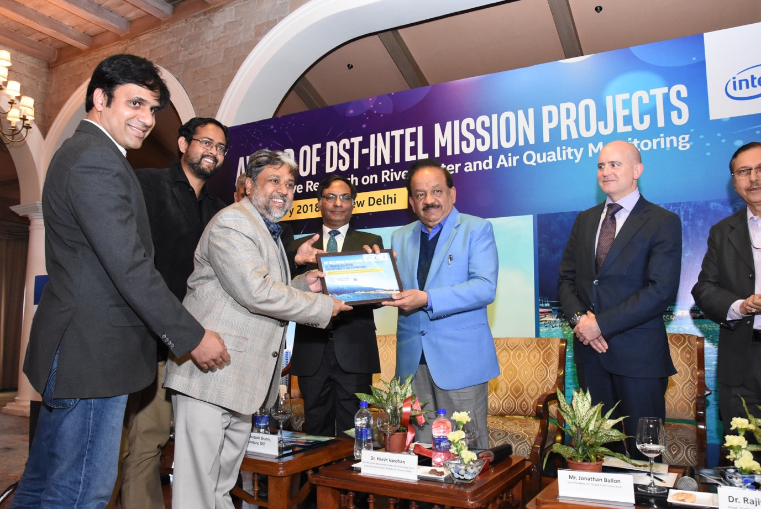

* 2018: Award of DST-Intel Mission Projects on “River Water Monitoring” [Award given by the Honorable Minister of Science and Technology of India, Dr. Harsh Vardhan]

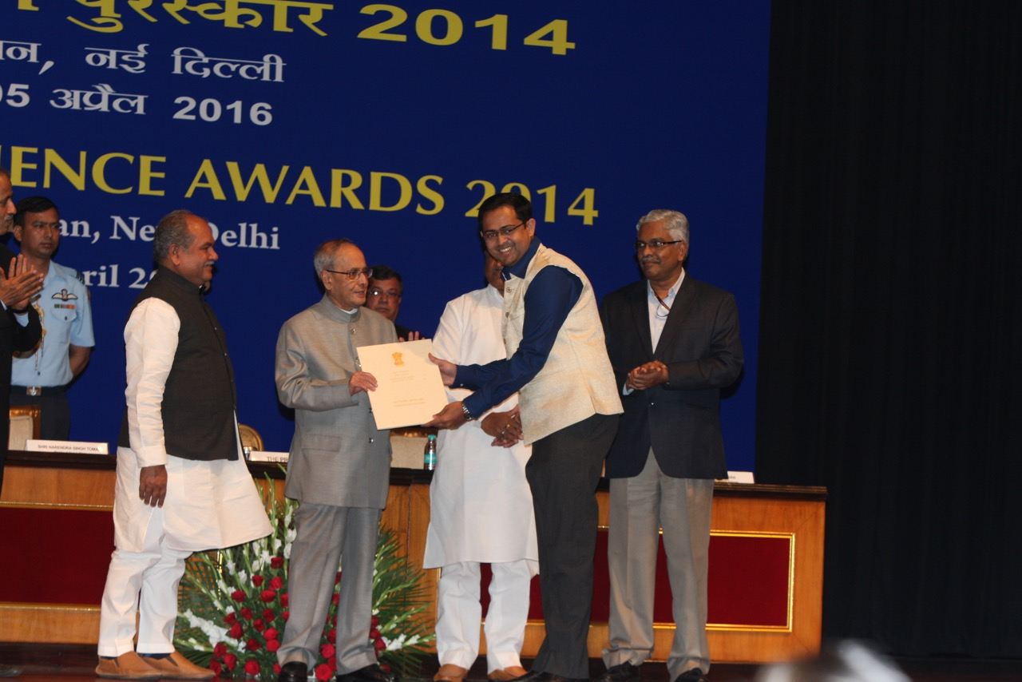

* Young Scientist Award Ministry of Mines. Award given by the Honorable President of India, Shri Pranab Mukherjee]

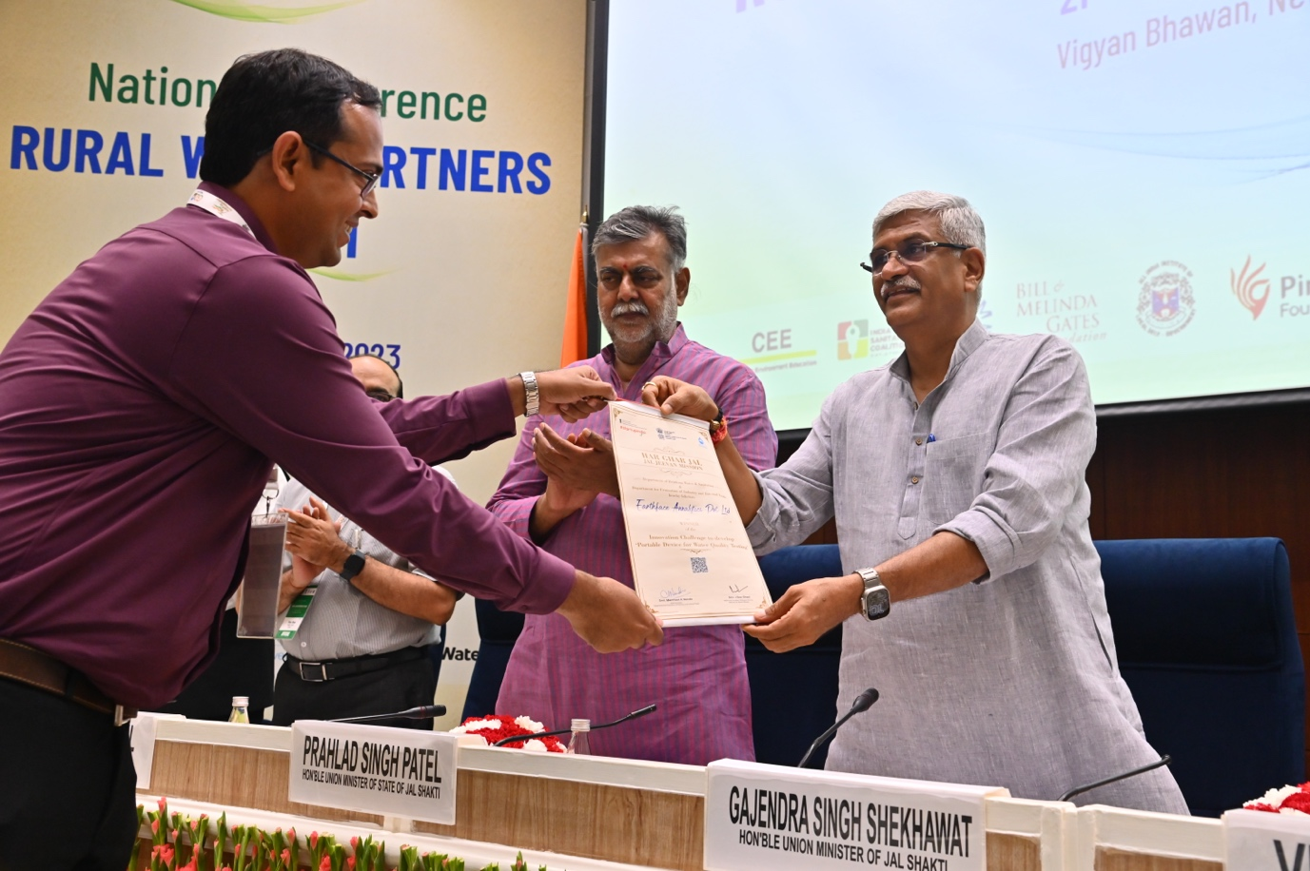

* National Water Quality Challenge Award. Given by the Honorable Union Minister of Jal Shakti, Shri Gajendra Singh Shekhawat